# Artificial Intelligence – CS561 (Assignment 1)

Chandan Satti (150101059) I.N.Dilip Kumar(150101027) Kushal KSVS(150101031)

The aim of the assignment was to carry out an MCMC technique- Metropolis-Hastings algorithm to sample probability distributions to fit the proposed function. The main aspect of the algorithm arises for the probability of a jump:

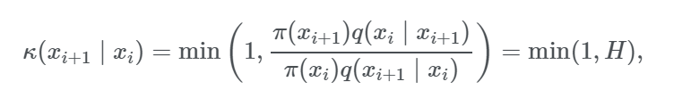

We change the sigma values as: 0.05, 1 and 50. The graphs of the histogram of samples and chain trace i.e. the samples vs iterations.

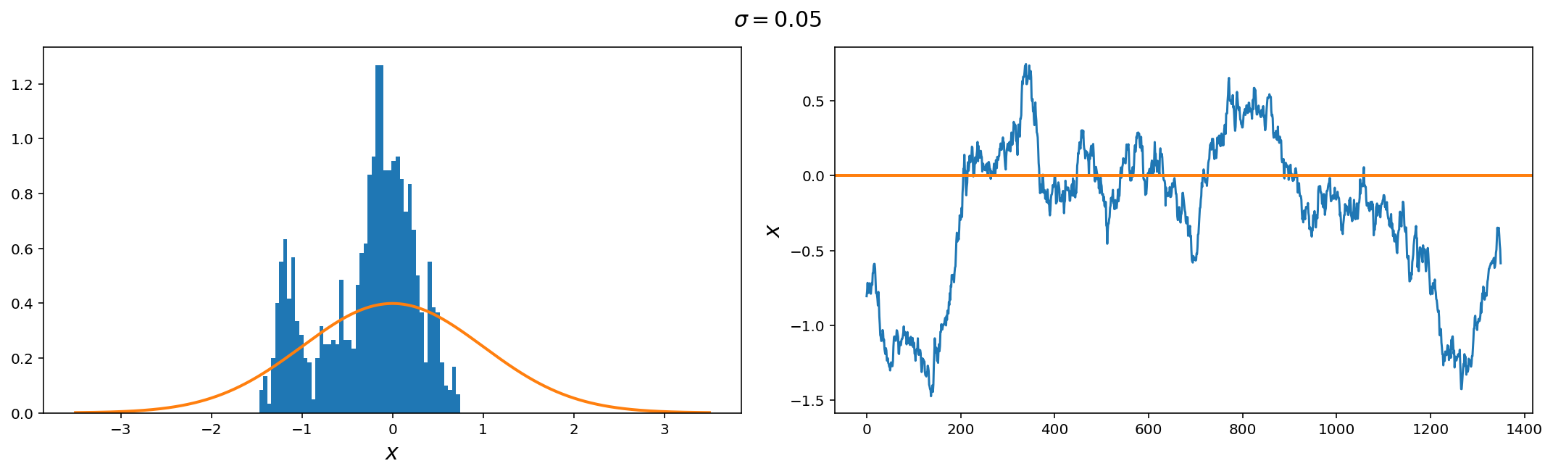

For the value of sigma = 0.05 which is very small, the trace of samples varies very slowly around the mean. In this case, the number of samples around mean is very high showing that it reached the maxima and the probability of reaching edge values became very low.

For sigma = 1, plot is:

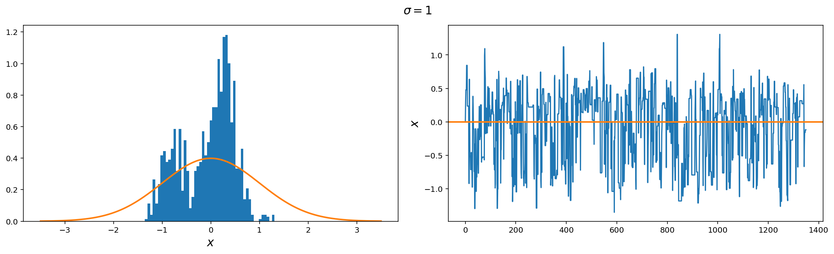

The jump size of 1 gave the best approximation to the proposed probability distribution function even though there are areas of high samples around maxima, the samples did reach outliers, also inferred from the samples vs iterations that it varies around the mean value which is 0.

For sigma = 50 plot is:

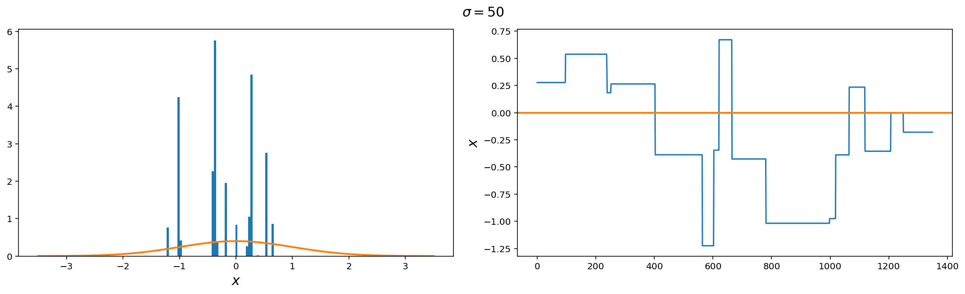

For the high value of jump size, the plot has almost all of the samples at fixed locations in the graph. Also observed from the iterations that plot is straight line at many areas showing that value remains some over the iterations.

Conclusion:

In an optimally performing MCMC, the histogram of samples should converge to the posterior distribution, the trace of the chain should sample around the maximum of the posterior such that the samples are close to i.i.d (independent, identical distribution).

Observed, when the jump size or sigma value is too low the graph misses values completely while in the case when it is too high it gets fixed at particular location. Hence, the sigma value must be showing, the above given performance of an optimally performing MH-algorithm.